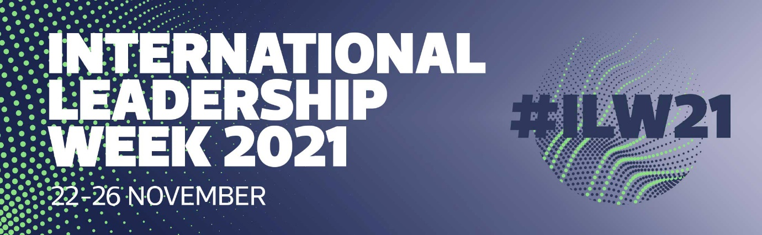
Join me and over 40 other international thought leaders, speaking at International Leadership Week 2021.
Running over 5 days, ILW21 will be packed full of thought-provoking discussions with high-profile thought leaders from across the globe. There will be a combination of interviews, panel discussions and presentations with the opportunity for audience members to ask questions of our expert speakers.
This year’s theme is: leadership re-invented.
Traditional leadership thinking has taken the heat in the last 2 years - not least because of the global pandemic we have all endured. We’ve been thrust into rapid change and adapting to new ways of working, often without the experience or know-how. So, The Institute have engaged leaders from around the world to deliver actionable insights and practical advice based on real life experiences.
I’ll be hosting my webinar on DATE at TIME to share my knowledge on TOPIC.
Reserve your FREE place now: BOOKING LINK
Other topics include: purpose, comfort zones, mindset, empowerment, change and resilience, plus many more...
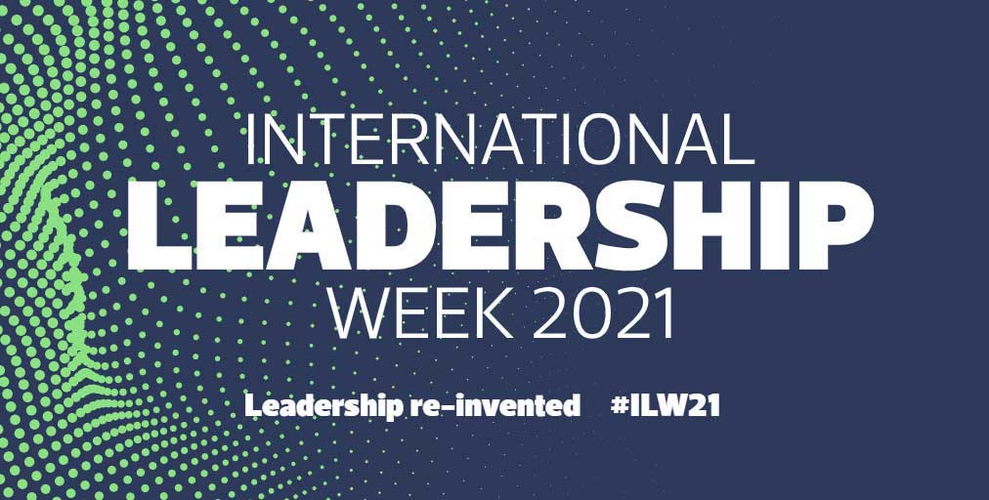

About The Institute and International Leadership Week
International Leadership Week is the halo annual virtual event created by The Institute of Leadership & Management to share insights and stories of the global leadership issues that affect us all. The Institute acts as the pivotal platform to highlight the voices of our international leadership community and to amplify, communicate, and discuss global leadership issues with a practical emphasis.
It’s the unmissable, annual event for global leaders.

